**Quovo Coding Challenge**

**By Allen Zhao**

**allenzhaojob@gmail.com**

**Running Enviroment:**

Python 3.x

Have BeautifulSoup installed

Have tabulate installed

**Running Instruction:**

** 0001166559 in the example is the CIK, you can replace it with any other CIK/Ticker

Method 1:

type in Terminal/Command Prompt : python SECwebMining.py 0001166559

Method 2:

type in Terminal/Command Prompt : python SECwebMining.py

when you see "Please Enter CIK/Ticker (eg. 0001166559): ", type in the CIK/Ticker

**Output**:

File information and Form 13F filing table, including every holding information

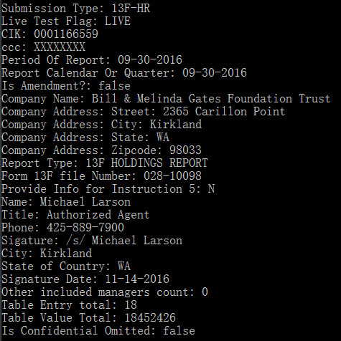

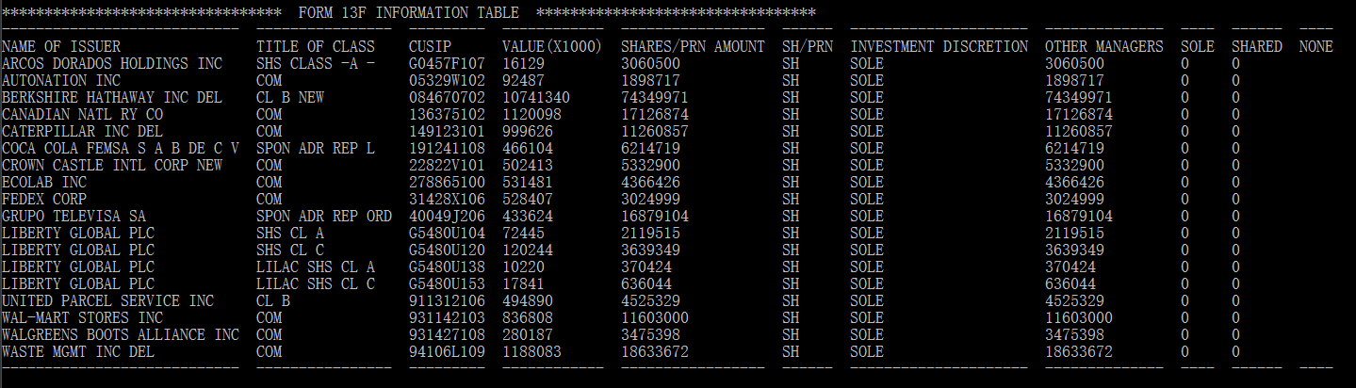

**Future thoughts and Summary:**

This is an interesting and fun coding challenge. And thanks to this challenge, I had a chance to get in touch with SEC website and all these holdings information. By using this program, we can retrieve all the holdings information, and I think next step could be getting information not only about the percentage of share a company is holding with others, we can also perform trending analysis on this data. For example, we can find which field where major investors are sending their money to and then we can make multiple strategies to coop with these trending respectively.

While writing the code, I tried to input a lot Tickers and found basically 2 types of 13F-HR format (there might be more), one with pre-parsed data and the other with raw xml data. For the first one, we can just utilize the pre-parsed data and retrieve the table. For the second type, we need to parse the data and construct the table. Firstly, I use BeautifulSoup lib to parse the data into HTML, and then parse the HTML on two different sections. the first half is the company and filing information, the second part is all the holdings info. After running the program, we can get the result as show in the above figures.

Please feel free to contact me if detailed information is needed.

Thank you! :D

Allen Zhao

250 Central Ave

Newark, NJ

862-371-5234

2017-02-09